6. Finite Word length Effects
6.1 Uniform Quantization and Quantization Error Analysis of a Discrete-Time Sinusoidal Signal Using MATLAB

Program (MATLAB Code)
clc;
clear;
close all;

%% Signal
fs = 1000;
f = 50;
t = 0:1/fs:0.1;
x = sin(2*pi*f*t);

%% Quantization Levels
L = [8 16 32];
colors = {'r','g','m'};

figure;

for i = 1:length(L)

% Uniform Quantization
xq{i} = round(((x + 1) * (L(i) - 1) / 2)) * (2 / (L(i) - 1)) - 1;

% Error & MSE
e{i} = x - xq{i};
mse(i) = mean(e{i}.^2);

% Plot Quantized Signal
subplot(4,1,i+1);
stairs(t, xq{i}, colors{i}, 'LineWidth', 1.2);
title(['Quantized Signal (' num2str(L(i)) ' Levels)']);
xlabel('Time (s)');
ylabel('Amplitude');
grid on;
end

%% Original Signal
subplot(4,1,1);
plot(t, x, 'b', 'LineWidth', 1.5);
title('Original Signal');
xlabel('Time (s)');
ylabel('Amplitude');
grid on;

%% Display MSE
fprintf('MSE for 8 Levels = %f\n', mse(1));
fprintf('MSE for 16 Levels = %f\n', mse(2));
fprintf('MSE for 32 Levels = %f\n', mse(3));

%% Error Plots
figure;

for i = 1:3
subplot(3,1,i);
plot(t, e{i}, 'k', 'LineWidth', 1);
title(['Quantization Error (' num2str(L(i)) ' Levels)']);
xlabel('Time (s)');
ylabel('Error');
grid on;
end
Output
MSE for 8 Levels = 0.010473
MSE for 16 Levels = 0.001763
MSE for 32 Levels = 0.000357

Fig 1
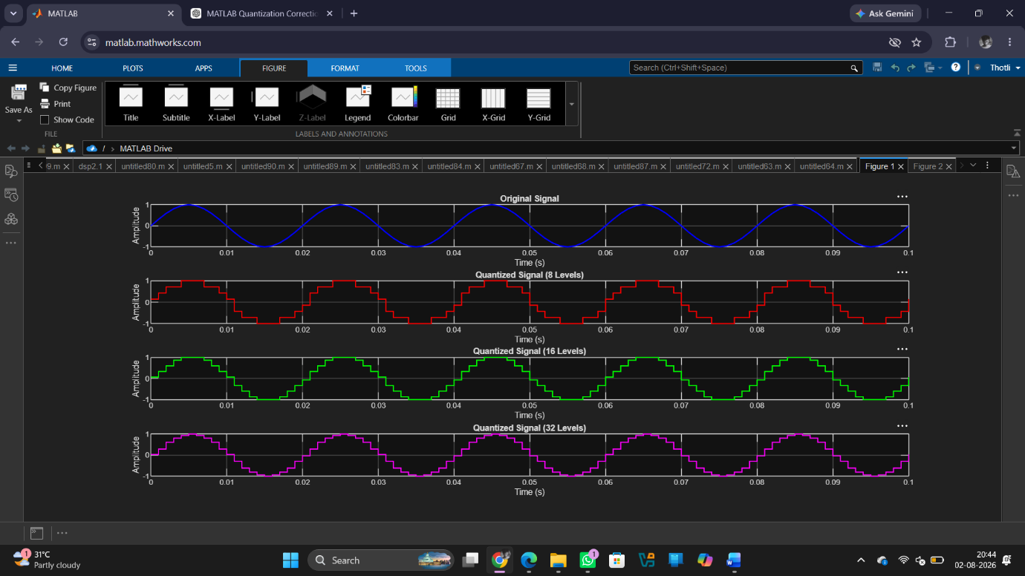

Fig 2
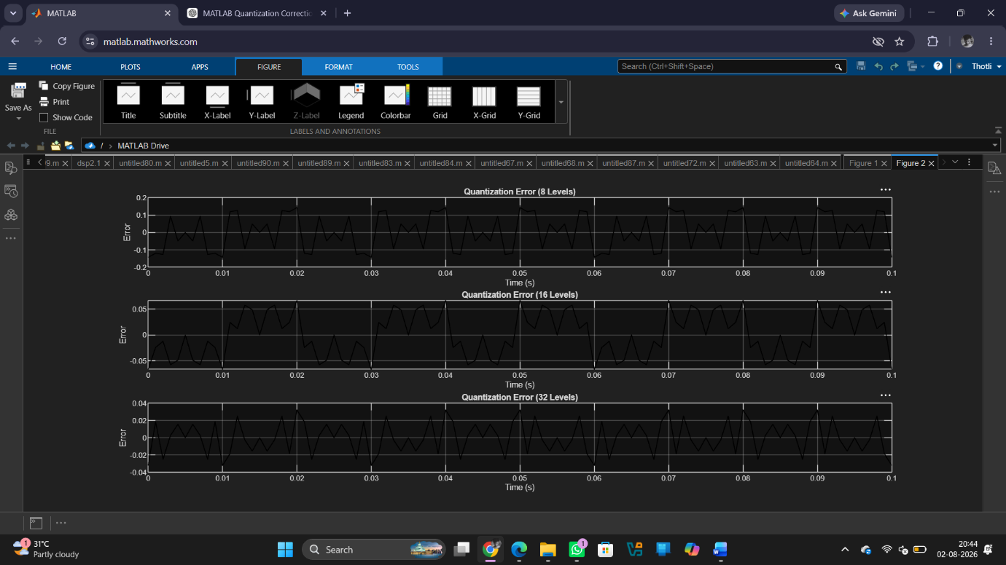
Result
1. A discrete-time sinusoidal signal was successfully generated in MATLAB.
2. Uniform quantization was performed for different quantization levels, and the corresponding quantized signals were obtained.
3. Comparison of the original and quantized signals showed that the quantized signal approximates the original signal more closely as the number of quantization levels increases. 4. The quantization error was analysed and found to decrease with increasing quantization levels, resulting in improved signal quality and reduced quantization noise.

